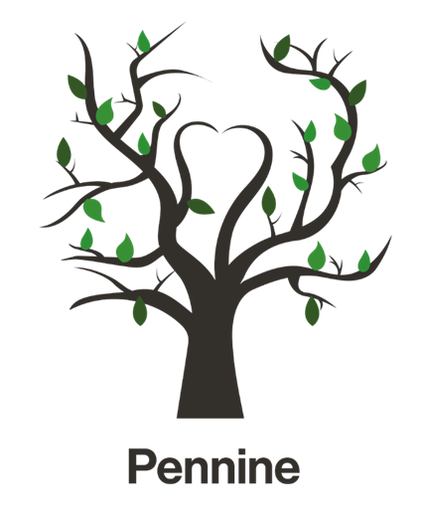

School Curriculum Policy

Approved by | Name Board of Directors | Date September 2026
Reviewed on |  | Date
Review due |  | Date

Applies to:
- The whole school inclusive of activities outside of the normal school hours.
- All staff (teaching and support staff), the proprietor and volunteers working in the school.

Purpose:
The purpose of the curriculum at Pennine School is:
- To provide a broad, balanced, ambitious and engaging curriculum that meets the individual needs, interests and aspirations of every pupil.
- To establish a coherent and consistent curriculum framework that supports progression across all key stages and pathways.
- To develop pupils' knowledge, skills and understanding across academic, vocational, personal and social domains.
- To ensure all pupils acquire and apply the literacy, communication, numeracy and digital skills needed for learning, daily life and future success.
- To inspire curiosity, foster a love of learning and promote positive attitudes towards education.
- To support pupils to develop confidence, resilience, independence and self-regulation through nurturing relationships and high expectations.
- To promote pupils' physical, emotional, mental and social wellbeing, enabling them to thrive both in school and beyond.
- To provide meaningful opportunities for enrichment, creativity, leadership, community engagement and personal achievement.
- To develop the employability, life and career management skills required for successful transitions into further education, training, employment and adulthood.
- To enable pupils to gain recognised qualifications and accreditation that celebrate achievement and support future progression.
- To promote spiritual, moral, social and cultural development, encouraging pupils to become respectful, responsible and active citizens.
- To prepare pupils for life in modern Britain by fostering an understanding of diversity, equality, democracy, individual liberty and mutual respect.
- To equip pupils with the knowledge, experiences and cultural capital needed to make informed choices, contribute positively to society and achieve their full potential.

1. Curriculum Rationale
At Pennine School, we recognise that many of our pupils join us having experienced significant barriers to education, often alongside Social, Emotional and Mental Health (SEMH) needs. As a result, our curriculum is designed to provide a nurturing, inclusive and supportive environment where pupils can rebuild confidence, re-engage with learning and experience success.
Our curriculum is underpinned by our PEAKS values of Providing Nurture, Encouraging Growth, Aspiring through Experience, Kindness and Resilience, and Supporting Achievement. These values shape both what we teach and how we teach it, ensuring that pupils are supported academically, socially, emotionally and personally.
We believe that strong relationships, high expectations and a sense of belonging are fundamental to successful learning. Therefore, our curriculum is carefully adapted to meet the individual needs, interests and aspirations of our pupils whilst maintaining ambition and providing pathways to recognised qualifications and meaningful outcomes. Through a personalised approach, we support pupils to develop confidence, resilience, communication skills, emotional regulation, independence and self-belief.
Alongside strong foundations in English, mathematics and science, our curriculum provides rich and meaningful experiences that broaden horizons, raise aspirations and prepare pupils for the next stage of their lives. Opportunities for enrichment, careers education, outdoor learning, ASDAN qualifications, AQA Unit Awards and wider community engagement help pupils develop the knowledge, skills and cultural capital needed for success in education, employment and adulthood.
We recognise that learning is about far more than academic achievement. Our curriculum places equal importance on personal development, wellbeing and character education. Through explicit teaching of social skills, emotional literacy, resilience and healthy relationships, pupils develop the confidence to navigate the challenges of modern life and make positive contributions to their communities.
At the heart of our curriculum is a commitment to preparing pupils for successful futures. We aim to develop independent, resilient and ambitious young people who understand their strengths, value their achievements and are equipped with the skills, experiences and qualifications needed to thrive in further education, employment and adult life.
We also believe that reading is the foundation upon which learning is built. Reading is promoted and celebrated across the curriculum, enabling pupils to access knowledge, develop vocabulary, think critically and engage more fully with the world around them. Through exposure to a wide range of high-quality texts and regular opportunities to read for purpose and pleasure, we foster a lifelong appreciation of reading and learning.

1.1 Core components
Our curriculum consists of 4 key components:
1. Access to high quality teaching in all areas of the curriculum
2. Strong focus on reading
3. Creative, adaptive curriculum
4. Preparation for next steps
1. Our curriculum is broadly based around the National Curriculum, offering all pupils the opportunity to gain qualifications in the core subject areas. Staff are aware of the need to deliver the curriculum in a more creative way than pupils may have experienced previously. This will include the use of tangible resources, learning outside of the classroom and relating learning to pupils’ real-world experiences.
2. We recognise that each pupil will be joining us at different emotional and academic starting points in their reading journeys and as such we are committed to providing an inclusive and supportive reading environment tailored to the unique needs of our pupils. Our goal is to ensure that each of our pupils develop into enthusiastic, confident readers who can competently decode texts both functionally and for meaning and enjoyment at their own pace.
3. We offer a curriculum that is personalised to the needs and interests of each pupil, formalised following in-depth assessments of each pupils’ abilities, needs and preferences. We employ a flexible approach to teaching, using a variety of methods and resources to cater to different learning styles, alongside creative use of learning outside of the classroom.
4. Another key element of our curriculum is the emphasis on preparing pupils to become active, responsible citizens and to develop practical life skills that foster independence and self-reliance. Our program includes citizenship education that explores rights and responsibilities, community engagement, and democratic processes. We also facilitate critical thinking and problem-solving through discussions and debates on current issues. Our curriculum offers life skills training in areas such as financial literacy, cooking, personal hygiene, and time management. Careers education is a vital and prominent aspect of our work with pupils.

1.2 Core Values
Our Pennine PEAKS Values
At Pennine School, our curriculum is underpinned by our PEAKS values, which shape our culture, guide our decision-making and influence everything we do. These values reflect our commitment to providing an education that supports pupils academically, socially, emotionally and personally, ensuring they are equipped to succeed both in school and beyond.
Through our PEAKS values, we strive to create a safe, nurturing and ambitious learning environment where every pupil feels valued, supported and inspired to achieve their full potential.
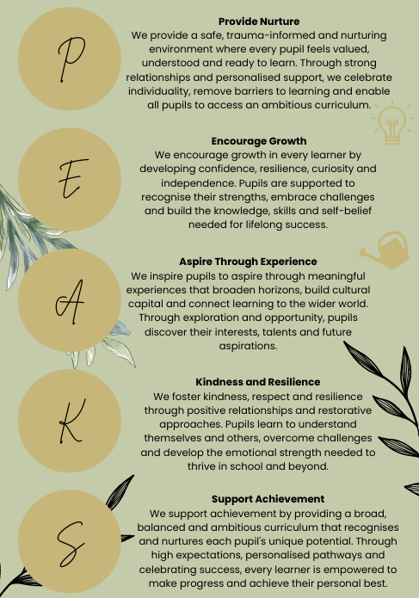
2. Intent
At Pennine School, our curriculum is designed to provide a broad, balanced, ambitious and engaging education that enables every pupil to succeed academically, socially and emotionally, regardless of their starting point. Rooted in our PEAKS values, and delivered through high-quality teaching, meaningful experiences and personalised support, we seek to develop confident, resilient and independent learners who are prepared for the next stage of their education and future lives. Our curriculum builds strong foundations in English, mathematics and science, while promoting communication, literacy, numeracy and personal development. Through enrichment opportunities, careers education, outdoor learning, ASDAN qualifications, AQA Unit Awards and accredited pathways, pupils develop the knowledge, skills, cultural capital and aspirations needed to thrive in further education, employment and adulthood. Ultimately, we aim to ensure every pupil leaves Pennine as a confident, ambitious and well-rounded young person, equipped to make a positive contribution to society and achieve their full potential.
2.2 Curriculum drivers
At Pennine we have four curriculum intentions that act as drivers for what we deliver:
A Sense of Self: Our curriculum will ensure that all pupils develop an understanding of themselves and an awareness of their place within the community.
Learning to Learn: Our curriculum offer will ensure that all pupils develop secure learning to learn behaviours focused around exploration, resilience and perseverance, working with others and problem solving.
Knowledge and Skills: Our curriculum offer will ensure that all pupils develop appropriate subject specific knowledge, skills and understanding in line with their stage of development.
Experience and Enrichment: Our curriculum offer will ensure that all pupils experience a breadth of opportunities and activities that expand horizons within and beyond the traditional learning environment of the classroom.

3. Implementation
Our curriculum is implemented through The Pennine Way Teaching Principles our evidence-informed approach to teaching and learning. Rooted in current educational research, The Pennine Way provides a consistent framework for high-quality teaching across the school and reflects our commitment to ensuring that every pupil can thrive, regardless of their starting point. At its core is our belief that:
"Through strong relationships, explicit instruction, meaningful practice and high expectations, we enable every pupil to feel safe, succeed and achieve their personal best."
The Pennine Way ensures that teaching is structured, inclusive and responsive to the needs of our pupils. We recognise that many pupils benefit from predictable routines, strong relationships and carefully scaffolded learning experiences. Therefore, teaching is delivered through a model that prioritises emotional safety, develops engagement and supports pupils to build confidence as learners.
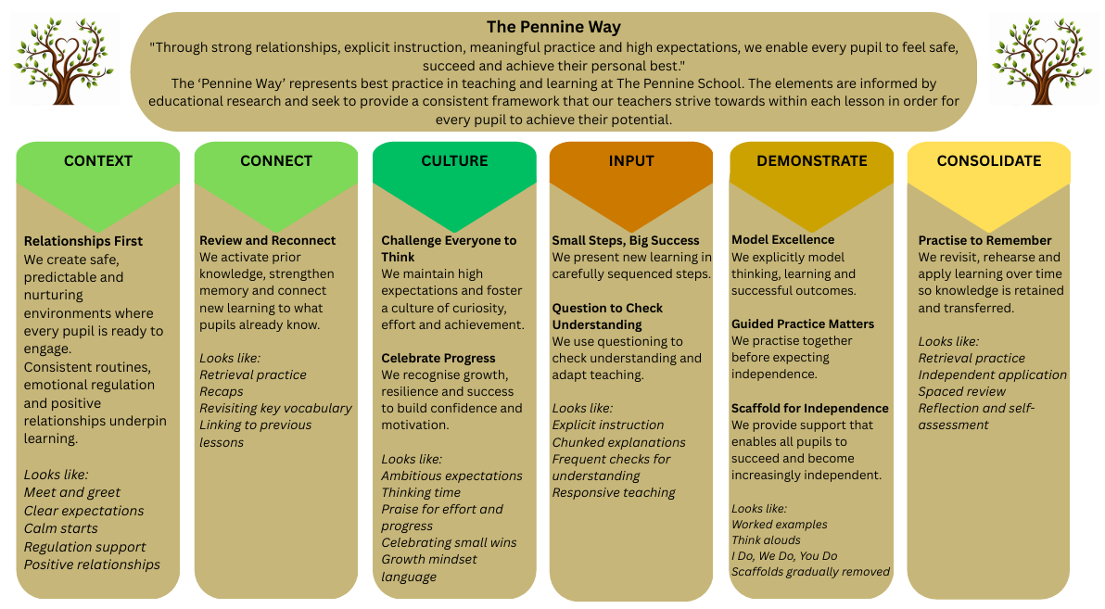
Our approach focuses on creating positive relationships and a culture of success, ensuring pupils feel valued, supported and motivated to achieve. Learning is carefully sequenced, new knowledge is presented in manageable steps and teachers use explicit instruction, questioning and modelling to develop understanding. Guided practice and appropriate scaffolding enable pupils to experience success while developing increasing independence. Regular retrieval practice, review and opportunities to apply learning help pupils retain knowledge and make meaningful connections across the curriculum. Through high expectations, responsive teaching and the celebration of progress, we support all pupils to make strong academic, social and personal progress.
3.1 Curriculum Delivery
Pupils are taught within age-related year groups, ensuring they access an ambitious, age-appropriate curriculum alongside their peers. Teaching is carefully adapted and scaffolded to meet individual needs, enabling all pupils to access learning at an appropriate level while making progress towards their personal, academic and developmental goals.

Structure of the school day
Time | Session
8.45am – 9.00am | Pupil arrival and breakfast
9.00am – 9.20am | Tutor group
9.20am – 10.00am | Lesson 1
10.00am – 10.40am | Lesson 2
10.40am – 11.20am | Lesson 3
11.20am – 12.00pm | Lesson 4
12.00pm – 12.20pm | Lunch break
12:20pm-12:40pm | Lunch break
12.40pm – 1.00pm | Tutor group
1.00pm – 1.40pm | Lesson 5
1:40pm-2:20pm | Lesson 6
2:20pm-2:30pm | Tutor group
Education staff will plan mini structured breaks within lessons when appropriate, these can be planned around the needs of each class. These breaks can happen inside or outside of the classroom.
 | Maths | English | Science | Humanities/  PSHE/RSE | Life matters* | Reading | Enrichment
Year 6 | X5 40 mins | X5 40 mins | X5 40 mins | X5 40 mins | X5 20mins | X5 20mins | X10 40mins
Year 7 | X5 40 mins | X5 40 mins | X5 40 mins | X5 40 mins | X5 20mins | X5 20mins | X10 40mins
Year 8 | X5 40 mins | X5 40 mins | X5 40 mins | X5 40 mins | X5 20mins | X5 20mins | X10 40mins
Year 9 | X5 40 mins | X5 40 mins | X5 40 mins | X5 40 mins | X5 20mins | X5 20mins | X10 40mins
Year 10 | X5 40 mins | X5 40 mins | X5 40 mins | X5 40 mins | X5 20mins | X5 20mins | X10 40mins
Year 11 | X4 40 mins | X5 40 mins | X5 40 mins | X5 40 mins | X5 20mins | X1 40mins | X10 40mins

Additional
Given the needs of the pupils, sessions focusing on life skills and social communication skills are also built into the timetable, these decrease in frequency as pupils move up the school and develop their skills in these areas.
- We teach using precise learning objectives and differentiated success criteria.
- We facilitate learning using a diverse range of learning tasks and strategies borne out of in-depth knowledge of our pupils and using targets derived from EHCPs and ILPs.
- Where appropriate, we use ‘cold’ (pre) tasks to check for prior understanding and plenaries to check that our pupils have fully understood the objective of the lesson, and if they haven’t, we adapt our plans and spend time with pupils to ensure they do, before moving on.
- We plan and teach in reference to our assessment milestones and pupils’ progress plans which identify pupils’ next steps (targets) in learning, communication and interaction and social and emotional wellbeing.
- We ensure the best possible environment for learning by developing a positive atmosphere in which pupils feel safe and that they belong, enjoy learning and being challenged, trust that they can take risks with their learning and know that they can and will succeed.
- We ensure that teaching and curriculum builds on previous learning through a learning sequence and that constant praise, engaging learning tasks and positive use of our behaviour system keeps pupils motivated.
- Some pupils may have bespoke curriculums with planned interventions that align with targets derived from EHCP and ILP information.
Academic interventions are in place for Maths, English and Reading. Pupils who need that extra support to enhance their Numeracy and Literacy are provided with extra sessions that are in small groups or 1:1. With this support identified at an early stage, we can ensure that our pupils have the necessary numeracy and literacy skills for later life.
Social interventions are also part of our daily programme, where pupils have the opportunity to develop their social development; this allows us to focus on the social and emotional aspects of learning, namely self-awareness, managing feelings, motivation, empathy and social skills.

3.2 Key Stages
The key stage 2 curriculum is designed to prepare pupils for the next stage of their education and to enable them to transition smoothly into key stage 3. Not all pupils will be ready to make this transition at the end of year 6 with their peers and for this reason we have mixed classes to allow a slow transition.
In key stage 3 pupils are taught in classes also of the same ability/need rather than age, with also ability ranges taken into consideration. This allows work to be targeted at the correct level for each grouping. All teaching is in line with the National Curriculum but broken down into small manageable sizes for delivery to pupils. Regular brain and movement breaks are arranged for pupils who have a need for this.
Life skills and social communication are also timetabled in accordance with the cohorts needs, some classes have a higher allowance than others of these sessions. All teaching at key stage 3 is aimed at providing a solid base for pupils moving on to key stage 4.
At key stage 4 and 5 pupils have some flexibility to choose the subjects that align with their future interests in careers. Pupils have core lessons in English and Maths alongside subjects of their choosing. The curriculum is designed to ensure that all pupils can leave the setting with a minimum achievement in all core subjects at various levels. Careers advice and teaching is also included in the key stage 4 and 5 curriculum at a higher level than at other key stages, this is to enable pupils confidence in making the correct decisions about their futures.
Post –16 Curriculum
It is important that pupils have access to an ambitious and relevant post-16 provision. We intend to offer opportunities for pupils to fill gaps in their key stage 4 education by offering the chance to sit GCSE subjects in English and Maths., alongside Geography, Science and Food tech. This will be our foundation academic pathway.
We also want to promote high expectations and encourage aspiration, so we intend to offer A level opportunities in English Literature, English Language and Maths. This will be our Advanced academic pathway.
A vocational pathway may also be relevant for some of our pupils so we will offer routes to this through links with local AP providers such as 4Tech Motor vehicle and Preston Vocational Centre.
All post-16 pupils will also be offered the general curriculum which covers PSHE and life skills.
The intent behind the post-16 provision is to personalise it for the individual pupils on entry and build on prior learning. This will be reflected in the consultation process when considering places for pre and post 16 pupils.
Enrichment Offer
At Pennine School, we believe that learning extends beyond the classroom and plays a vital role in developing confident, resilient and well-rounded young people. Our enrichment offer is an integral part of the curriculum and is designed to broaden horizons, raise aspirations and provide pupils with the knowledge, skills and experiences needed for success in education, employment and adult life.
Structured around nationally recognised themes, our enrichment programme places a particular emphasis on life skills, personal development and careers education. Through a diverse range of activities and experiences, pupils develop communication, teamwork, leadership, resilience, independence and problem-solving skills while building confidence and self-esteem.
Our enrichment offer includes opportunities within:
- Life Skills
- Civic Engagement
- Nature and the Outdoors
- Sports and Physical Activities
- Arts and Culture
Pupils participate in a range of enriching experiences, including Forest School, Food Technology, educational visits, community projects and careers-focused activities. These experiences help pupils develop practical skills, independence, social awareness and a greater understanding of the world around them.
In addition, pupils have the opportunity to achieve recognised accreditation through ASDAN qualifications, AQA Unit Awards and other accredited programmes. These qualifications recognise achievement in areas such as personal development, employability, community engagement and preparation for adulthood, enabling pupils to celebrate success and build a portfolio of achievements for their next steps.
Through our enrichment curriculum, pupils are encouraged to discover new interests, challenge themselves, contribute positively to their communities and develop the cultural capital, life skills and aspirations needed to thrive in modern society. Ultimately, our enrichment offer supports pupils to become confident, independent and ambitious young people who are well prepared for their future.

Curriculum Planning and Schemes of Work

The following information is intended as an overview. Individual subject detail is contained in the curriculum overview documents.

Pennine curriculum documents and schemes of work cover all year groups (ages 10–18) and the following subject areas as required by the Independent School Standards Regulations 2014:
- English
- Mathematics
- Science
- ICT (Information and Communication Technology)
- Human and Social (Geography/History)
- Physical Education (PE)
- Aesthetic and Creative (Art, Music, Drama)
- PSHE (Personal, Social, Health and Economic Education)

These subjects will be taught in a way that ensures pupils acquire new knowledge, develop skills, and deepen understanding progressively throughout the term and year.

All subject areas demonstrate:
- A broad and balanced curriculum
- Effective teaching and assessment
- Evidence of pupil progress
- Integration of British values
- Adaptation for pupils with special educational needs

Curriculum Structure
- Pennine has a written curriculum policy, supported by plans and schemes of work that reflect the ages, aptitudes, and needs of all pupils, including those with EHCPs.
- Our curriculum promotes British values.

Teaching Methodology
- Teaching is adapted, inclusive, and responsive to pupils’ needs.
- We use project-based learning, cross-curricular themes, and subject integration.
- We use a blended and holistic approach, adapting the curriculum to individual pupils rather than expecting pupils to adapt to the curriculum.

Assessment Opportunities
- Continuous assessment is required to monitor progress.
- We use baseline assessments, formative and summative assessments, and progress tracking.
- Reading, writing, and numeracy are emphasised, with targeted interventions for pupils falling behind.

Evidence of Progression
- Pupils must show progress over time in knowledge, skills, and understanding.
- Pennine demonstrate progression through:
- Yearly curriculum overviews
- Subject-specific progression maps
- Schemes of work tailored to each year group
- Assessment tools

Integration Across Subjects
- Subjects are not always taught separately at Pennine.
- We do integrate subjects through themes, projects, or interdisciplinary units.
- For example, combining English, History, and Art in a unit on “Victorian Britain” or integrating Science and Geography in a “Climate Change” project.

PLEASE NOTE: Key stage 5 provision
Pennine’s curriculum for key stage 5 is aimed at pupils who have not yet achieved GCSE qualifications. For those pupils that achieve GCSE in year 11 we would support them attending college to study relevant qualifications for key stage 5.

English
Tasks | - Reading comprehension (fiction & non-fiction)  - Creative writing (short stories, poetry)  - Analytical essays (literature analysis)  - Oral presentations and debates
Teaching methodology | - Whole-class instruction, guided reading, peer review  - Use of classic and contemporary texts  - Integration of drama and role-play
Assessment | - Written assignments  - Reading logs and book reviews  - Speaking & listening evaluations
Progression | - Vocabulary expansion  - Improved grammar and syntax  - Critical thinking and literary analysis
Key progression milestones | - Ages 10–12 (Years 6–7): Develop foundational literacy—reading fluency, grammar, and creative writing.  - Ages 13–14 (Years 8–9): Begin literary analysis, persuasive writing, and structured essays.  - Ages 15–18 (Years 10–13): Prepare for GCSE English Language and Literature—critical reading, comparative texts, and exam techniques.

Mathematics
Tasks | - Arithmetic, algebra, geometry, statistics  - Problem-solving challenges  - Real-world applications (e.g., budgeting)
Teaching methodology | - Interactive lessons with manipulatives  - Use of digital tools (e.g., graphing software)  - Differentiated instruction
Assessment | - Topic tests and quizzes  - Project-based assessments  - End-of-term exams
Progression | - Mastery of core concepts  - Development of logical reasoning  - Application of mathematical models
Key progression milestones | - Ages 10–12 (Years 6-7): Master basic arithmetic, shapes, and data handling.  - Ages 13–14 (Years 8-9): Introduce algebra, geometry, and problem-solving strategies.  - Ages 15–18 (Years 10-13): GCSE prep—cover all strands including statistics and trigonometry.

Science
Tasks | - Lab experiments and investigations  - Research projects  - Scientific reports
Teaching methodology | - Inquiry-based learning  - Hands-on practicals  - Use of simulations and models
Assessment | - Lab reports  - Concept quizzes  - Group presentations
Progression | - Understanding scientific method  - Application of theory to practice  - Development of analytical skills
Key progression milestones | - Ages 10–12 (Years 6-7): Explore basic biology, chemistry, and physics concepts.  - Ages 13–14 (Years 8-9): Conduct experiments and understand scientific principles.  - Ages 15–18 (Years 10-13): GCSE Science—triple or combined science with practical assessments.

ICT
Tasks | - Coding projects (Python, HTML)  - Digital presentations  - Data analysis using spreadsheets
Teaching methodology | - Project-based learning  - Flipped classroom for software tutorials  - Collaborative tasks
Assessment | - Portfolio of digital work  - Peer and self-assessment  - Practical exams
Progression | - Digital literacy  - Programming proficiency  - Responsible use of technology
Key progression milestones | - Ages 10–12 (Years 6-7): Build digital literacy and internet safety awareness.  - Ages 13–14 (Years 8-9): Learn coding basics, multimedia tools, and data handling.  - Ages 15–18 (Years 10-13): GCSE ICT—cover theory and practical applications.

Human & Social (Geography/History)
Tasks | - Map reading and data interpretation  - Historical timelines and essays  - Case studies (e.g., climate change, revolutions)
Teaching methodology | - Thematic units  - Use of primary sources and fieldwork  - Debates and role-play
Assessment | - Source analysis  - Research projects  - Written exams
Progression | - Understanding cause and effect  - Evaluating evidence  - Global awareness
Key progression milestones | - Ages 10–12 (Years 6-7): Study local geography and ancient history.  - Ages 13–14 (Years 8-9): Explore global issues and historical events.  - Ages 15–18 (Years 10-13): GCSE Geography/History—fieldwork, source analysis, and thematic studies.

PE
Tasks | - Team sports and individual fitness  - Health and nutrition projects  - Leadership roles in sport
Teaching methodology | - Skill-based instruction  - Inclusive and adaptive activities  - Goal setting and reflection
Assessment | - Performance tracking  - Fitness assessments  - Self and peer evaluations
Progression | - Physical competence  - Teamwork and resilience  - Healthy lifestyle habits
Key progression milestones | - Ages 10–12 (Years 6-7): Develop movement skills and teamwork.  - Ages 13–14 (Years 8-9): Focus on fitness, health education, and leadership.  - Ages 15–18 (Years 10-13): GCSE PE—practical performance and sports theory.

Aesthetic & Creative (Art, Music, Drama)
Tasks | - Art portfolios and exhibitions  - Musical compositions and performances  - Drama productions
Teaching methodology | - Studio-based learning  - Exploration of cultural influences  - Collaborative creation
Assessment | - Creative journals  - Performance reviews  - Peer critiques
Progression | - Artistic expression  - Technical skill development  - Cultural appreciation
Key progression milestones | - Ages 10–12 (Years 6-7): Explore basic techniques in art, music, and drama.  - Ages 13–14 (Years 8-9): Develop performance and composition skills.  - Ages 15–18 (Years 10-13): GCSE Art/Music/Drama—portfolio work and public showcases.

PSHE (Personal, Social, Health & Economic Education)
Tasks | - Discussions on relationships, mental health, careers  - Budgeting and financial planning  - Community service projects
Teaching methodology | - Circle time and open forums  - Scenario-based learning  - Guest speakers and workshops
Assessment | - Reflective journals  - Group projects  - Participation and engagement
Progression | - Emotional intelligence  - Social responsibility  - Life skills and independence
Key progression milestones | - Ages 10–12 (Years 6-7): Learn about emotions, friendships, and safety.  - Ages 13–14 (Years 8-9): Discuss mental health, relationships, and diversity.  - Ages 15–18 (Years 10-13): Prepare for adult life—finance, careers, and wellbeing.

4.Impact
By implementing an adapted and modified curriculum, it is intended that Pennine will:
- Optimise the communication skills of all pupils.
- Cater for the specific needs and learning difficulties of individual pupils as described in their EHCPs (if applicable), by providing teaching and learning opportunities at an appropriate level.
- Engage pupils’ interests in personal development and encourage learning.
- Create a positive learning environment where pupils can work safely.
- Allow pupils to interact and learn from each other.
- Allow all pupils to reach their full potential and achieve their own personal success.
- Give pupils opportunities to develop their key skills.
- Pupils will be enthused by learning and achieve positive outcomes.
- Pupils will remember what they learn and make progress in all subject areas.
- Pupils will leave us with a reading age beyond a functional level and they will be well prepared for the next stage of learning
- Pupils will achieve a range of nationally recognised qualifications, including English and Maths, and will have achieved the outcomes and targets outlined on their EHCPs and ILPs.
- Pupils will have identified possible career pathways in line with their strengths and interests.
- Pupils will be socially and emotionally prepared for transition to further education, employment or training.
- Pupils will feel accepted and valued and will demonstrate improved self-esteem and confidence.
- Pupils will know how to keep themselves safe and healthy and they will have developed a range of positive coping strategies.
- Pupils will have an awareness of their rights and responsibilities, and they will be able to express their own views effectively.
- Pupils will demonstrate respect, kindness and pride, and an ability to form positive relationships with both peers and adults alike.

A Sense of Self
Pupils have a positive self-image, high well-being and engagement and are able to relate well to members of the school community. They take pride in themselves, their learning and the school environment.

Learning to Learn
Pupils are active participants in their learning who are keen to take part and work with others. They have developed a ‘have a go’ attitude and are able to draw on previous experiences in order to solve new problems.

Knowledge and Skills
Pupils demonstrate incremental progress in their subject knowledge and skills. They are able to retain and apply this over time and in different contexts. Pupils require reduced levels of support to access their leaning and their fluency and accuracy is improved.

5. Monitoring
The school’s usual monitoring activities ensure that the curriculum offered is progressive and appropriate, enabling all pupils to achieve positive outcomes. Such monitoring activities include planning and work scrutiny, lesson visits and learning walks, which are carried out by senior leaders. See Pennine’s assessment policy for more detailed information, this includes Pennine’s quality assurance schedule.

6. Roles and responsibilities
Directors ensure that:
- The curriculum is fit for purpose and meets all the requirements of the Independent School Standards.
- All pupils are offered a broad and engaging curriculum, which is well sequenced and leads to positive outcomes.
- There is regular monitoring and quality assurance to evaluate the effectiveness of the school and its curriculum implementation.
- School leaders are ambitious for their pupils and that the curriculum design reflects this.
- The school curriculum is meeting the needs of all learners and considers their individual needs and starting points.
- The relevant training and development are in place to support leaders and staff to continually develop and improve the implementation of the curriculum.
Leaders ensure that:
- Staff in the school are involved in decision-making processes that relate to the vision, intent and development of the curriculum.
- Regular monitoring activities are carried out to ensure that the curriculum offered is progressive and appropriate, enabling all pupils to achieve positive outcomes.
- All teaching staff fulfil their roles and responsibilities, including high quality planning and teaching methods, use of regular assessment and consistent implementation of the agreed school policies and procedures.
- Teachers are provided with opportunities to sustain strong subject knowledge and pedagogy as required and the whole-staff team remain upskilled in supporting the needs of pupils.
- Parents/carers receive regular communication from staff, including information about the curriculum and school strategies, their child’s progress and next steps.
The teaching staff ensure that:
- The curriculum is planned and delivered to support pupils to develop skills, knowledge and vocabulary, helping pupils to know more and remember more and to be prepared for their adult lives.
- The curriculum is planned and devised to best suit the needs of each individual pupil, and takes account of outcomes and strategies outlined in EHCPs, ILPs and any other key documents.
- A range of teaching and differentiation strategies are used to ensure all our pupils are stretched and able to progress at their own pace.
- Pupils are given the opportunity to experience safely planned activities outside of the usual classroom environment.
- Pupils know their next steps and how to get there, with opportunities to discuss their own learning.
- Parents and carers are provided with high-quality reports which reflect what their children have been learning and how they will be supported to progress.
- The procedures for assessment are used to support the learning and development of the pupils, including identifying gaps in knowledge and next steps.
- Subject leads provide support and advice for colleagues, and monitor progress in their subject area.
All staff ensure that:
- High expectations are maintained for our pupils and themselves at all times.
- Reading, learning and high aspirations are role-modelled by all members of the school community.
- Pupils are supported to express themselves appropriately socially and emotionally.
- Pupils are helped to develop their literacy and numeracy skills and achieve their next steps with increasing independence.
- Pupil achievements are celebrated, and positivity is promoted in all aspects of school life.
7. Legislation and guidance
This policy reflects the requirements of the National Curriculum programmes of study. It also reflects requirements for inclusion and equality as set out in the Special Educational Needs and Disability Code of Practice 2014 and Equality Act 2010, and refers to curriculum-related expectations of governing boards set out in the Department for Education’s Governance Handbook.
8. Policy review
The policy will be monitored in the following ways:
Regular Review: The curriculum will be reviewed at least annually to ensure it meets the evolving needs of our pupils and aligns with current best practices in specialist education.
Stakeholder Feedback: We will seek input from pupils, parents, staff, and external experts to continuously improve our curriculum offerings.
Outcome Measurement: Pupil progress will be tracked using a combination of qualitative and quantitative measures, ensuring that we effectively support their development.
Internal and external audits and quality visits: The effectiveness of the curriculum intent, delivery and outcomes will be reviewed through Governance, audits and quality assurance visits.
Further detailed information on the subjects taught in each year group are available on request (subject specific curriculum overview documents).

By adhering to this curriculum policy, we are committed to providing a holistic, enriching, and supportive educational experience that empowers our pupils to thrive both within and beyond the school environment.

