

Pennine School
Positive Behaviour Policy

Approved by | Name Board of Directors | Date September 2026
Reviewed on |  | Date
Review due |  | Date

Philosophy

Our starting point is always our mission statement:

Believe you can achieve

We are a community where you can feel safe, secure and able to flourish.
Here, our differences and diversity are celebrated

As such, our school believes in the positive management of behaviour. We aim for all the children to achieve their maximum potential in a caring and safe environment. We accept that children make mistakes and believe it is the responsibility of all the adults in the school to help the children to learn from their mistakes. We aim for our children to become independent and self-regulated learners.

Underpinning our philosophy in behaviour management is the nurture principles set out by Nurture UK. The school has adopted these principles in school life, to best provide our children with a safe and calm environment in which they can flourish.

The principles act as a guiding framework to the behaviour policy and the manner in which we assess, support and respond to the behaviour displayed by our children. The six principles are:

- Children's learning is understood developmentally
- The classroom offers a safe base
- Nurture is important for the development of self-esteem
- Language is understood as a vital means of communication
- All behaviour is communication
- Transitions are significant in the lives of children

The importance of good behaviour
The school ethos is based upon a positive, consistent and structured approach to appropriate behaviour support where expectations are clearly modelled and communicated to provide a secure environment. The ability to adapt behaviour which is appropriate to a variety of situations is an essential life skill. We believe that it is our responsibility to help children to understand the importance of good behaviour and therefore learn to make the right choices at school and as future citizens.

In implementing this policy, the school will:
- Establish systems which are consistent throughout the school and which are clearly communicated to children, parents, carers and staff
- Encourage children to respect the needs and well-being of others
- Promote by example, acceptable standards of behaviour
- Encourage positive relationships throughout the school community
- Consider the special needs of individual children
- Encourage children to incorporate respect for everyone and everything into their daily lives.

Roles and Responsibilities

The Board of Directors should:
- Ensure that the policy is updated regularly by the Headteacher and reflects the ethos of the school

The Headteacher should:
- Promote a consistent approach throughout the school
- Support members of staff in their implementation of the school’s policies
- Oversee the implementation of the policy throughout the school
- Provide positive behaviour training at least annually and more regularly if required
- Ensure that the policy is reviewed and revisited annually

All staff should:
- Establish and encourage positive relationships
- Implement the school policies for behaviour

Parents and Carers should:
- Support the school in implementation of the policy to ensure a cohesive and cooperative approach to supporting their child’s behaviour

Children should:
- Take responsibility for their actions

School Expectations
It is the belief of the board of directors and staff that close attention should be paid to ongoing day to day rules and regulations in order to establish a firm basis for courtesy and consideration for others. All staff, therefore, must use positive behaviour strategies to:

- Reinforce the codes of common decency and courtesy in order to help the children to grow up to be polite and caring members of society
- Make certain that children show respect for each other and for all members of the school community
- Encourage children to move around the school appropriately without running and with consideration for others
- Prevent the use of inappropriate language
- Encourage children to show care for our school environment
- Foster good relationships within our school

Below is a list of actions and strategies all staff working within Pennine School agree to implement:
- Smile – passing along positive energy and creating a sense of security and belonging
- Display only behaviour which you would want children to replicate.
Staff will demonstrate respectful interactions with all members of the school community
- Use of positive language (verbal and body)
E.g. please put your hand up rather than do not shout out and finished rather than no.
This also includes positive body language and the avoidance of fear, anger and frustration in adult behaviour.
- Giving time to ‘Noticing’ children will be a priority for all staff.
Children will be greeted positively when they enter the classroom. Staff should notice that children are not ready for learning, they will intervene with nurturing strategies (time out, 1-1 talk time, time with intervention staff) There will be tutor group time each morning to air out any difficulties the children have had either in the morning or previous evening, so the children have time to settle in to class and be ready to learn.

- Consistent recognition
The children will decide a tutor group target and all the children will work towards achieving this, once achieved the class will be rewarded. There will be a choice of non-tangible rewards available. This will help to promote responsibility.

- Consistent Celebration of children’s achievements through the presentation of ‘public praise’, notes and phone calls home.

- Closing the gap and turning down the volume
Staff will not correct behaviour in school by shouting over distances, through crowds, or over
noise. Signs, positive indicators, should be used wherever possible. Children will be spoken to
privately in behaviour correction to maintain the child’s self esteem

- Wait, watch, wonder
Becoming attuned to the child’s behaviour is key in assessing behaviour, preventing the
escalation of situations and connecting with the child. Staff will endeavour to think
empathetically when dealing with behaviour and understand that all behaviour is a form of
communication

- Staff Pledge
To enable consistencies throughout the school in which behaviour is dealt with the staff will make a pledge as follows:

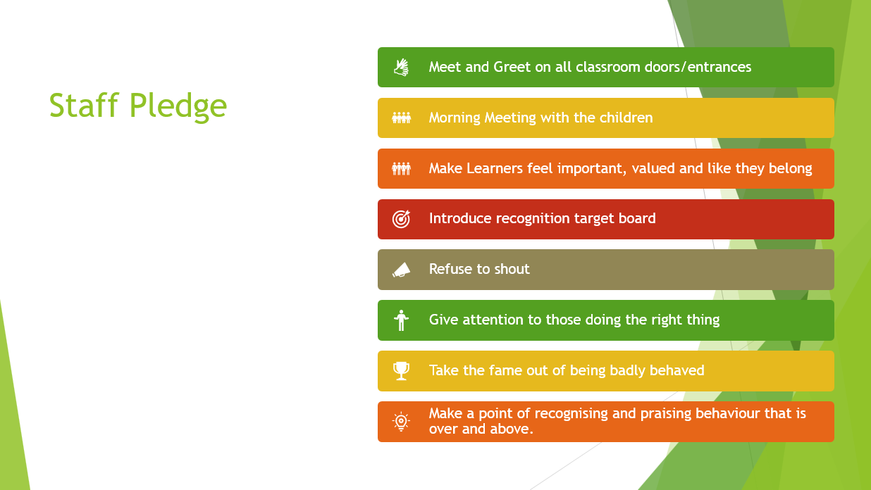

School Systems for Behaviour Management

  READY | - Ready to learn, ready to engage, ready to work, and ready to listen, ready to…
  RESPECTFUL | - Mutual respect, individual respect for EVERYONE, children, staff, parents, visitors.
  SAFE | - A right to a safe environment for both adults and children in all environments – classes, playground, offices, trips etc.

We have a therapeutic approach to managing behaviour. This is based on positive relationships.

Dealing with challenging behaviour
The member of staff will deliver a quiet reminder this will be done directly and privately to the child where possible. The child should be reminded of a previous positive behaviour. The intervention should take no longer than 30 seconds and be direct with no open questions.

Next steps
Use the agreed narrative (name, feeling, behaviour): Daniel I can see that you are frustrated as you’re finding this hard. Take 5 minutes in the safe space and then you’ll be ready to continue. Thank you.
If the child continues to behave negatively the next step would be to offer the child minutes in the quiet area to compose themselves and come back.
Continued support
In the event that extra support is needed the intervention team or pastoral support can be called and they will provide extra support for the child until which time they are ready to learn.

Restorative conversations

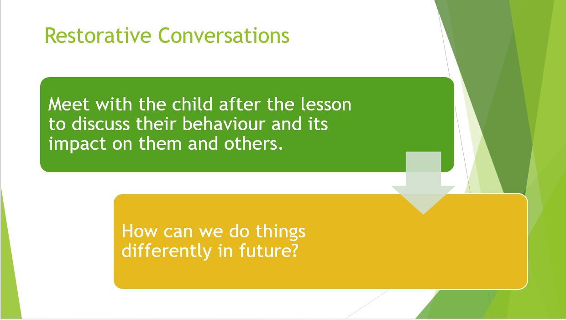

Recognition System
Every tutor room has a Recognition Board. These emphasise the positive contributions that children make to the class. The recognition board will be used to focus on target behaviours and children will be immediately rewarded for displaying that day’s target behaviour by having their name written on the board.

We want to encourage children to be motivated to learn, follow instructions, and follow the rules because they know that is the right thing to do. For a minority of children, they may need more incentive and support to behave well. In these circumstances positive behaviour plans may be used. With a focus on earning a reward for behaving appropriately. The use of a sanction for example timeout should be used when a child needs to self-regulate their behaviour. The adults need to provide safe places for the children to go and self-regulate, and they may need ‘tools’ to support their self-regulation. These should be requested from the inclusion team for the child when appropriate.

In addition to the daily recognition board there is another target set by pupils. Everyone is involved in the development of our emotional resilience and relationships approach. Children have a nominated chairperson in each class and have regular meetings to set targets (1 at a time) and discuss progress, in the early stages the chairperson can be assisted by the teacher this is to promote independence of thought and taking responsibility.

There will also be an opportunity for children to be recognised for going ‘above and beyond’ these children will be awarded with a choice of reward can be chosen by the child and be agreed by the class teacher.
Procedures
- The school’s ethos is that recognition and praise are more effective in the long term
- It is important that all staff should establish a positive and welcoming atmosphere for children by welcoming them inside the classroom on their arrival
- Acceptable behaviours should be discussed with children and their views (phrased in a positive way) posted on the classroom wall and reviewed. These should form the basis of the whole tutor group agreement developed at the beginning of each academic year with teachers and their class
- All school staff have the same authority as teachers in matters of behaviour, i.e. they are expected to insist on correct codes of behaviour and to issue routine recognition
- The Headteacher may in certain circumstances refer difficulties to parents and the Board of Directors
- SLT may determine whether the circumstances require that parents should be informed about behaviour issues

Sanctions and Restorative Actions
Behaviour levels, examples, sanctions, and restorative actions for staff reference.

Level | Behaviour Examples | Sanctions | Restorative Actions
Level 1 – Low-Level Disruption | Talking out of turn; Refusing to follow simple instructions; Minor disrespectful language; Distracting others; Not completing work despite reminders | Verbal reminder of expectations; Move seat within classroom; Loss of small privilege; Restorative conversation with staff | Brief restorative chat to repair relationships and reinforce expectations
Level 2 – Persistent Disruption or Minor Defiance | Repeated refusal to follow instructions; Leaving seat without permission; Mild verbal aggression; Ignoring staff after multiple prompts; Deliberately disrupting group activities | Time-out in designated area; Reflection sheet completed; Phone call home; Restorative meeting with staff | Structured restorative meeting to discuss impact and agree next steps
Level 3 – Serious Disruption or Aggressive Behaviour | Swearing directly at staff or peers; Throwing objects in anger; Walking out of the classroom without permission; Threatening language towards peers; Damaging classroom property | Removal to supervised calm space; Formal behaviour report logged; Meeting with pastoral team; Restorative session before return to class | Restorative conference with staff and pupil before reintegration
Level 4 – High-Risk or Dangerous Behaviour | Physical aggression; Serious damage to property; Attempting to leave school site; Bringing prohibited or dangerous items; Behaviour posing immediate risk to self or others | Immediate removal to safe space; Senior leadership involvement; Fixed-term exclusion if risk cannot be managed; Individual behaviour plan review; Multi-agency meeting if needed | Full restorative conference with family and professionals before reintegration

Safety and Wellbeing
Children’s safety and well-being is of paramount importance to us and when a child, adult or children are in danger we take the following steps:

Intervention and Pastoral Support
Key rooms have been identified in school where pupils can seek support or are timetabled for specific interventions. These rooms are Intervention, Therapy Rooms, Sensory Room, and the PE suite of rooms. A member of the intervention team or pastoral support team should always be available throughout the day to offer advice to staff that are struggling with pupils that are not engaging in lessons; whether they are distracting others with a lack of study focus or bringing issues or concerns into school that are affecting their usual settled patterns of behaviour. The team will encourage support staff to offer pupils the opportunity to talk things through and encourage the development of personal strategies to help the pupil through times of difficulty during the school day. Support staff are encouraged to use the intervention room with pupils to minimise disruption on the classroom corridors.

Corridors will be monitored by staff throughout the day to ensure pupils have someone to talk to in the event of them being unsettled in class. The intervention team carry out targeted programmes, such as Maths and English boosters, in a 1:1 or small group setting or can assist pupils who are struggling to complete their work in class, by providing them with a change of face and a more settled environment to learn. The pastoral team can support pupils in making progress towards objectives concerning anger management, emotional responses, social responses, managing times of change, preparing for life post 16, developing life skills and developing speaking and listening skills. These staff track and record all sessions for analysis and assessment.

Intervention Room
This room is the base for the intervention team, providing a welcoming environment for pupils to come and engage in their learning. There are numerous timetabled intervention sessions on throughout the day with different intervention staff.

Sensory Room
The sensory room is a calm space that pupils can access. It offers a safe space where pupils can regulate their emotions through play, lights, or quiet time.
There are targeted sessions timetabled in the sensory room with intervention staff. The room can also be used as a reward or a place to carry out restorative justice meetings, if appropriate.
Due to the expensive equipment in this room, pupils will not be permitted entry if they appear in any way distressed. Pupils and staff must remove shoes on entry to the sensory room.
The room is also available for staff use, when appropriate.

Boxing Room
This is a small space that has a padded seated area, large wall pads, a large punch/kick bag and coloured LED lights. There is a control panel for the lights that will change the colour, speed and brightness. The intervention team and SLT can access this room for pupils to use when distressed. It is a great resource to use before any conversations are attempted with pupils that have been involved in an incident.

Other PE Rooms
These include a cardio room, weights room, wellbeing room and the hall.

De-escalation and physical intervention
All staff are trained to follow the strict guidelines of de-escalation techniques and the use of physical intervention. At all times staff endeavour to employ the de-escalation techniques over physical intervention. However, there are times when a young person’s behaviour demands that staff must intervene and use reasonable force to decrease the risks to themselves and/ or others present.
Staff should only use physical intervention if they have undertaken approved training, to prevent injury to a young person or adult. In these circumstances, staff must always act in a manner consistent with the values and principles set out by the school. Any intervention used must:
a. Not impede the process of breathing;
b. Not be used in a way which may be interpreted as sexual;
c. Not intentionally inflict pain or injury or threaten to do so;
d. Avoid vulnerable parts of the body, e.g. the neck, chest and sexual areas.
e. Avoid extending the joints beyond the normal limits or range of motion (hyperextension or hyperflexion), and pressure on or across the joints.
f. Not employ potentially dangerous positions.
Emphasis on training and education will be on dealing effectively with situations to obviate the need for restraint. Conflict Resolution training is mandatory for all employees working directly with young people and renewed every year.
Training is renewed on an annual basis, is offered by our internal training team and is quality assured by PRICE TRAINING LIMITED (https://www.pricetraining.co.uk/your-sector/childrens-services/)
Use of reasonable force
School staff have a legal power to use reasonable force and lawful use of the power will provide a defence to any resulting action.
Force is usually used either to control or restrain. It must never be used as a punishment; this is always unlawful.
What is reasonable force?
1) The term ‘reasonable force’ covers the broad range of actions used by most teachers at some point in their career that involve a degree of physical contact with pupils.
2) Force is usually used either to control or restrain. This can range from guiding a pupil to safety by the arm through to more extreme circumstances such as breaking up a fight or where a pupil needs to be restrained to prevent violence or injury.
3) ‘Reasonable in the circumstances’ means using no more force than is needed
4) Schools generally use force to control pupils and to restrain them.
'Control' means either passive physical contact, such as standing between pupils or blocking a pupil's path, or active physical contact such as leading a pupil by the arm out of a classroom.
- 'Restraint' means to hold back physically or to bring a pupil under control. It is typically used in more extreme circumstances, for example when two pupils are fighting and refuse to separate without physical intervention.
5) School staff should always try to avoid acting in a way that might cause injury, but in extreme cases it may not always be possible to avoid injuring the pupil.
Who can use reasonable force?
1) All members of school staff have a legal power to use reasonable force.
2) This power applies to any member of staff at the school. It can also apply to people whom the Headteacher has temporarily put in charge of pupils such as unpaid volunteers or parents accompanying pupils on a school organised visit.
When can reasonable force be used?
1) Reasonable force can be used to prevent pupils from hurting themselves or others, from damaging property or from causing disorder.
2) In a school, force is used for two main purposes – to control pupils or to restrain them.
3) The decision on whether or not to physically intervene is down to the professional judgement of the staff member concerned and should always depend on the individual circumstances.
4) The following list is not exhaustive but provides some examples of situations where reasonable force can and cannot be used.
Schools can use reasonable force to:
· Remove disruptive pupils from the classroom where they have refused to follow an instruction to do so.
· Prevent a pupil behaving in a way that disrupts a school event or a school trip or visit.
· Prevent a pupil leaving the classroom were allowing the pupil to leave would risk their safety or lead to behaviour that disrupts the behaviour of others.
· Prevent a pupil from attacking a member of staff or another pupil, or to stop a fight in the playground; and
· Restrain a pupil at risk of harming themselves through physical outbursts
Staff and pupils involved in any incident will need to ensure that there is an opportunity to repair and rebuild any damage done to the positive relationships between staff and pupils. An RF1 must be completed by all staff involved in a physical restraint.

All incidents of physical restraint are reported to the Directors anonymously on a termly basis and reviewed as part of the monitoring process of school performance.

Exclusion
Serious breaking of school rules or extended periods of unacceptable behaviour that pose a Health, Safety, Well-being or Safeguarding risk may result in exclusion from the school, usually for a fixed term. Exclusions are carried out according to DfE and Directorate guidelines. Exclusion can only be approved by the Head Teacher, or Deputy in their absence. In all cases of exclusion, parents/carers are notified of their rights to make representations to the board of directors. Behaviours that may lead to exclusion are assaults on staff and pupils, criminal damage to the building or equipment and possession of prohibited items. Each serious incident will be dealt with on an individual basis, and we will always work to maintain positive relationships as a priority.

In line with current legislation if a pupil is excluded for more than 5 days then suitable full-time provision should be provided from the 6th day. If a pupil is excluded for more than 1 day then work will be sent home for Maths and English and any other work, if appropriate, for the days missed. We will also arrange a home visit to be carried out by the School Social Worker to check on the wellbeing of the pupil and offer support for the family.
Parents/carers are required to ensure that their child is not allowed to be out and about during school hours during the period of exclusion. A young person seen during school hours is liable to a fixed penalty fine.

Following any fixed term exclusion, the parent/carer will be invited for a reintegration meeting. However, failure to attend such a meeting would not be allowed to prevent the pupil returning to school. In emergency circumstances a telephone meeting can be held.
On an extremely rare occasion a decision may be made to permanently exclude a pupil. This is a situation that we will always try to avoid and will only occur when there is no other way to manage a pupil in school.

Absconding
Although the areas that pupils will access are safe and secure, we understand that, at times, there may be incidents where pupils may leave the site without permission. In these circumstances we would notify parents/carers as soon as possible. If this becomes a repeated act, we would review the pupil’s individual risk assessment. Where appropriate, depending on pupil history and individual circumstances, the local police would be notified.

Smoking
Pennine is a non-smoking establishment, although we would be naïve to not acknowledge some pupils are smokers. Duty staff are vigilant in noting any pupils they see smoking at break times. If pupils are caught smoking on school premises their tutor will be informed who will then discuss with parents/carers. This applies to e-cigarettes also.

Mobile phones and prohibited items.
At Pennine, we recognise that mobile phones and similar devices are an important part of everyday life. However, to maintain a calm, safe, and supportive learning environment, the use of mobile phones by pupils during the school day is strictly regulated in accordance with the latest government guidance (Department for Education, 2024).

Health and safety legislation requires a school to be managed in a way which does not expose pupils or staff to risks to their health and safety and this would include reasonable rules as a condition of admittance onto school premises.

Pupils attending Pennine should not have any of the listed prohibited items on their person in school.
Prohibited items are:
- aerosols
- mobile phones*
- knives or weapons
- alcohol
- illegal drugs
- stolen items
- tobacco, cigarette papers, lighters, matches
- fireworks or fun snaps
- pornographic images
  - any article that the member of staff reasonably suspects has been, or is likely to be, used: to commit an offence, or to cause personal injury to, or damage to the property of, any person (including the pupil)

*Mobile phones are allowed to be used appropriately on transport only, to and from school. Mobile phones cannot be used for taking pictures, videos or videos calling while on transport.
All pupils are asked to lock their mobile phone away in their tutor room safe on arrival.

If staff suspect, are informed of, or see pupils with any of the prohibited items they should ask for that item to be handed in. Any pupil refusing to do this should, in the first instance, have a phone call home. Parent/carer should be informed that their child is refusing to hand in a prohibited item and that the school would have no choice but to send their child home for refusing to comply with school rules. This is not classed as exclusion but treated as unauthorised absence. The parent/carer would need to pay the cost of the transport in this case. Following the phone call, which may or may not involve the child speaking to their parent/carer, the pupil should then be given a last chance to hand the item in. If the pupil refuses this final time, then SLT should be informed, and the office will arrange transport. It may be more appropriate for the police to be called to assist, depending on the prohibited item the pupil has on them.
additional information for staff will be provided on the S.O.P (standard operational procedure) documentation.

Strategies to Encourage and Support Good Behaviour:
- Asking support staff to spend regular one to one time with small groups for a specified period, or to hold small circle-time group sessions
- Adopting a more proactive approach during circle times and raising behavioural issues
- Giving learners an overview each morning of the day ahead to alleviate anxieties and insecurities by using a class visual timetable.

SEND and Vulnerable Children
For the vast majority of children these strategies will be effective in developing emotional intelligence and resilience. For a small proportion of children, the approach may need to be adapted to suit their specific needs. In this case, these adaptations are agreed with the Head teacher and Intervention and pastoral teams resulting in clear, consistent strategies recorded on the child’s positive behaviour plan. These are shared with ALL adults who work with the child.

Dissemination of Rules and Regulations
All staff are asked to reinforce rules on an as needs basis but to avoid negativity and actively promote positivity. The Headteacher communicates with the whole school where necessary, again in a positive manner. All staff are provided with training in behaviour management.

End of the Day Routines
Staff Form teams meet at the end of every day to discuss the pupils individually and other matters arising from the day such as safeguarding concerns and positive achievements. These comments and discussions are recorded on Arbor (MIS) and can then be used for meetings with parents etc. Any decisions regarding sanctions are also discussed at the meeting and logged on Arbor. All incidents including damage, racism and bullying should also be recorded on Arbor during this meeting.

The Intervention and Pastoral Support Teams have a separate end of day meeting where matters from the day are discussed and logged. The teams look at all incidents logged on Arbor and ensure actions are taken so the incident can be resolved. The staff on these teams are responsible for communicating with all staff to ensure actions happen and the incident is resolved. SLT are available for advice and guidance.

Multi agency support
We acknowledge that some pupils may need additional support to manage their behaviour and that as a school we need to seek advice from more experienced professionals. Parents will always be informed and consent obtained before we involve any other agencies with pupils.

